**Obj and mtl file explanations**

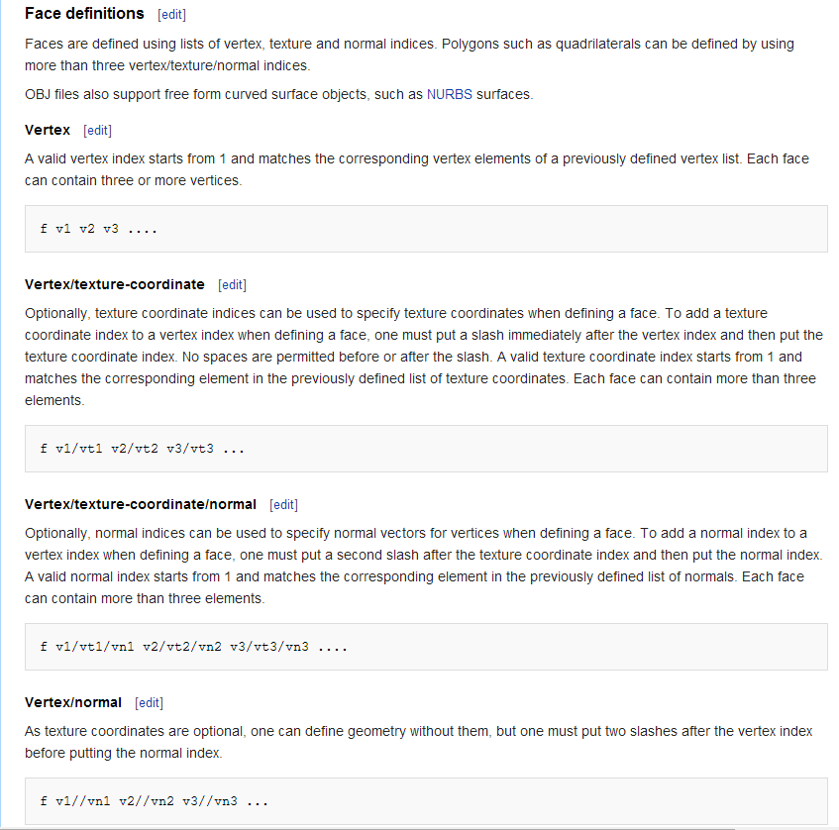

Example

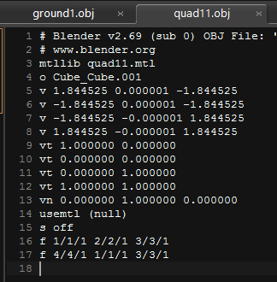

if you look at the last two line

we're drawing a plane, defined by two triangles

this gives a complete looking plane

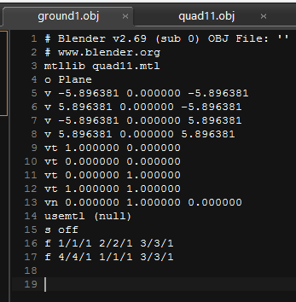

but if you look at this one, the plane will look like this

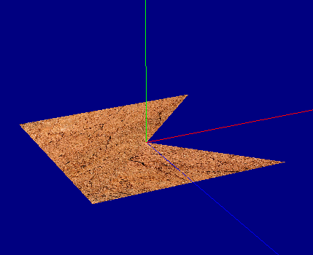

Links

http://en.wikipedia.org/wiki/Wavefront_.obj_file